**JSON**

JavaScript Object Notation (JSON) is a standard text-based format for representing structured data based on JavaScript object syntax. It is commonly used for transmitting data in web applications (e.g., sending some data from the server to the client, so it can be displayed on a web page, or vice versa). You'll come across it quite often, so in this article, we give you all you need to work with JSON using JavaScript, including parsing JSON so you can access data within it, and creating JSON.

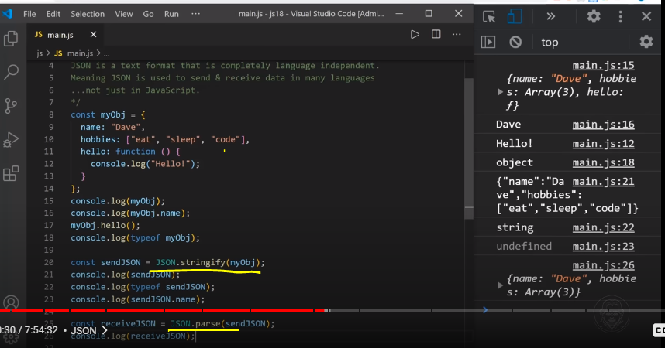

To convert JavaScript object to json file use JSON object

Example:

1. JSON.stringify(obj) to convert object into string(json)
2. JSON.parse(json) to convert string(json) to object

JSON is a text-based data format following JavaScript object syntax, which was popularized by Douglas Crockford. Even though it closely resembles JavaScript object literal syntax, it can be used independently from JavaScript, and many programming environments feature the ability to read (parse) and generate JSON.

JSON exists as a string — useful when you want to transmit data across a network. It needs to be converted to a native JavaScript object when you want to access the data. This is not a big issue — JavaScript provides a global JSON object that has methods available for converting between the two.

A JSON string can be stored in its own file, which is basically just a text file with an extension of .json, and a MIME type of application/json.

**JSON structure**

As described above, JSON is a string whose format very much resembles JavaScript object literal format. You can include the same basic data types inside JSON as you can in a standard JavaScript object — strings, numbers, arrays, booleans, and other object literals. This allows you to construct a data hierarchy, like so:

JSON

{

"squadName": "Super hero squad",

"homeTown": "Metro City",

"formed": 2016,

"secretBase": "Super tower",

"active": true,

"members": [

{

"name": "Molecule Man",

"age": 29,

"secretIdentity": "Dan Jukes",

"powers": ["Radiation resistance", "Turning tiny", "Radiation blast"]

},

{

"name": "Madame Uppercut",

"age": 39,

"secretIdentity": "Jane Wilson",

"powers": [

"Million tonne punch",

"Damage resistance",

"Superhuman reflexes"

]

},

{

"name": "Eternal Flame",

"age": 1000000,

"secretIdentity": "Unknown",

"powers": [

"Immortality",

"Heat Immunity",

"Inferno",

"Teleportation",

"Interdimensional travel"

]

}

]

}

Other notes

1. JSON is purely a string with a specified data format — it contains only properties, no methods.
2. JSON requires double quotes to be used around strings and property names. Single quotes are not valid other than surrounding the entire JSON string.
3. Even a single misplaced comma or colon can cause a JSON file to go wrong, and not work. You should be careful to validate any data you are attempting to use (although computer-generated JSON is less likely to include errors, as long as the generator program is working correctly). You can validate JSON using an application like JSONLint.
4. JSON can actually take the form of any data type that is valid for inclusion inside JSON, not just arrays or objects. So for example, a single string or number would be valid JSON.
5. Unlike in JavaScript code in which object properties may be unquoted, in JSON only quoted strings may be used as properties.

**Top-level function**

The top-level function looks like this:

JS

async function populate() {

const requestURL =

"https://mdn.github.io/learning-area/javascript/oojs/json/superheroes.json";

const request = new Request(requestURL);

const response = await fetch(request);

const superHeroes = await response.json();

populateHeader(superHeroes);

populateHeroes(superHeroes);

}

To obtain the JSON, we use an API called Fetch. This API allows us to make network requests to retrieve resources from a server via JavaScript (e.g. images, text, JSON, even HTML snippets), meaning that we can update small sections of content without having to reload the entire page.

In our function, the first four lines use the Fetch API to fetch the JSON from the server:

1. we declare the requestURL variable to store the GitHub URL
2. we use the URL to initialize a new Request object.
3. we make the network request using the fetch() function, and this returns a Response object
4. we retrieve the response as JSON using the json() function of the Response object.

Converting between objects and text

The above example was simple in terms of accessing the JavaScript object, because we converted the network response directly into a JavaScript object using response.json().

But sometimes we aren't so lucky — sometimes we receive a raw JSON string, and we need to convert it to an object ourselves. And when we want to send a JavaScript object across the network, we need to convert it to JSON (a string) before sending it. Luckily, these two problems are so common in web development that a built-in JSON object is available in browsers, which contains the following two methods:

parse(): Accepts a JSON string as a parameter, and returns the corresponding JavaScript object.

stringify(): Accepts an object as a parameter, and returns the equivalent JSON string.

You can see the first one in action in our heroes-finished-json-parse.html example (see the source code) — this does exactly the same thing as the example we built up earlier, except that:

we retrieve the response as text rather than JSON, by calling the text() method of the response

we then use parse() to convert the text to a JavaScript object.

The key snippet of code is here:

JS

async function populate() {

const requestURL =

"https://mdn.github.io/learning-area/javascript/oojs/json/superheroes.json";

const request = new Request(requestURL);

const response = await fetch(request);

const superHeroesText = await response.text();

const superHeroes = JSON.parse(superHeroesText);

populateHeader(superHeroes);

populateHeroes(superHeroes);

}

As you might guess, stringify() works the opposite way. Try entering the following lines into your browser's JavaScript console one by one to see it in action:

JS

let myObj = { name: "Chris", age: 38 };

myObj;

let myString = JSON.stringify(myObj);

myString;

Here we're creating a JavaScript object, then checking what it contains, then converting it to a JSON string using stringify() — saving the return value in a new variable — then checking it again.

**Various Advance Examples:**

[**Active learning: Working through a JSON example**](https://developer.mozilla.org/en-US/docs/Learn/JavaScript/Objects/JSON#active_learning_working_through_a_json_example)

So, let's work through an example to show how we could make use of some JSON formatted data on a website.

[**Getting started**](https://developer.mozilla.org/en-US/docs/Learn/JavaScript/Objects/JSON#getting_started)

To begin with, make local copies of our [heroes.html](https://github.com/mdn/learning-area/blob/main/javascript/oojs/json/heroes.html) and [style.css](https://github.com/mdn/learning-area/blob/main/javascript/oojs/json/style.css) files. The latter contains some simple CSS to style our page, while the former contains some very simple body HTML, plus a [<script>](https://developer.mozilla.org/en-US/docs/Web/HTML/Element/script) element to contain the JavaScript code we will be writing in this exercise:

HTML

<header>

...

</header>

<section>

...

</section>

<script>

...

</script>

We have made our JSON data available on our GitHub, at <https://mdn.github.io/learning-area/javascript/oojs/json/superheroes.json>.

We are going to load the JSON into our script, and use some nifty DOM manipulation to display it, like this:

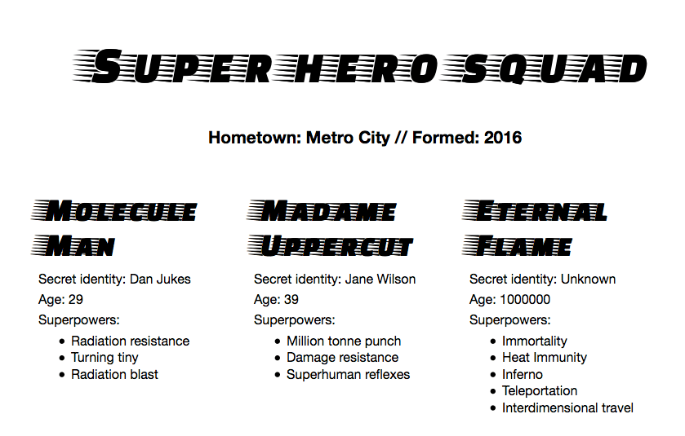

[**Top-level function**](https://developer.mozilla.org/en-US/docs/Learn/JavaScript/Objects/JSON#top-level_function)

The top-level function looks like this:

JS

async function populate() {

const requestURL =

"https://mdn.github.io/learning-area/javascript/oojs/json/superheroes.json";

const request = new Request(requestURL);

const response = await fetch(request);

const superHeroes = await response.json();

populateHeader(superHeroes);

populateHeroes(superHeroes);

}

To obtain the JSON, we use an API called [Fetch](https://developer.mozilla.org/en-US/docs/Web/API/Fetch_API). This API allows us to make network requests to retrieve resources from a server via JavaScript (e.g. images, text, JSON, even HTML snippets), meaning that we can update small sections of content without having to reload the entire page.

In our function, the first four lines use the Fetch API to fetch the JSON from the server:

* we declare the requestURL variable to store the GitHub URL
* we use the URL to initialize a new [Request](https://developer.mozilla.org/en-US/docs/Web/API/Request) object.
* we make the network request using the [fetch()](https://developer.mozilla.org/en-US/docs/Web/API/fetch) function, and this returns a [Response](https://developer.mozilla.org/en-US/docs/Web/API/Response) object
* we retrieve the response as JSON using the [json()](https://developer.mozilla.org/en-US/docs/Web/API/Response/json) function of the Response object.

**Note:** The fetch() API is **asynchronous**. We'll learn a lot about asynchronous functions in [the next module](https://developer.mozilla.org/en-US/docs/Learn/JavaScript/Asynchronous), but for now, we'll just say that we need to add the keyword [async](https://developer.mozilla.org/en-US/docs/Web/JavaScript/Reference/Statements/async_function) before the name of the function that uses the fetch API, and add the keyword [await](https://developer.mozilla.org/en-US/docs/Web/JavaScript/Reference/Operators/await) before the calls to any asynchronous functions.

After all that, the superHeroes variable will contain the JavaScript object based on the JSON. We are then passing that object to two function calls — the first one fills the <header> with the correct data, while the second one creates an information card for each hero on the team, and inserts it into the <section>.

[**Populating the header**](https://developer.mozilla.org/en-US/docs/Learn/JavaScript/Objects/JSON#populating_the_header)

Now that we've retrieved the JSON data and converted it into a JavaScript object, let's make use of it by writing the two functions we referenced above. First of all, add the following function definition below the previous code:

JS

function populateHeader(obj) {

const header = document.querySelector("header");

const myH1 = document.createElement("h1");

myH1.textContent = obj.squadName;

header.appendChild(myH1);

const myPara = document.createElement("p");

myPara.textContent = `Hometown: ${obj.homeTown} // Formed: ${obj.formed}`;

header.appendChild(myPara);

}

Here we first create an [h1](https://developer.mozilla.org/en-US/docs/Web/HTML/Element/Heading_Elements) element with [createElement()](https://developer.mozilla.org/en-US/docs/Web/API/Document/createElement), set its [textContent](https://developer.mozilla.org/en-US/docs/Web/API/Node/textContent) to equal the squadName property of the object, then append it to the header using [appendChild()](https://developer.mozilla.org/en-US/docs/Web/API/Node/appendChild). We then do a very similar operation with a paragraph: create it, set its text content and append it to the header. The only difference is that its text is set to a [template literal](https://developer.mozilla.org/en-US/docs/Web/JavaScript/Reference/Template_literals) containing both the homeTown and formed properties of the object.

[**Creating the hero information cards**](https://developer.mozilla.org/en-US/docs/Learn/JavaScript/Objects/JSON#creating_the_hero_information_cards)

Next, add the following function at the bottom of the code, which creates and displays the superhero cards:

JS

function populateHeroes(obj) {

const section = document.querySelector("section");

const heroes = obj.members;

for (const hero of heroes) {

const myArticle = document.createElement("article");

const myH2 = document.createElement("h2");

const myPara1 = document.createElement("p");

const myPara2 = document.createElement("p");

const myPara3 = document.createElement("p");

const myList = document.createElement("ul");

myH2.textContent = hero.name;

myPara1.textContent = `Secret identity: ${hero.secretIdentity}`;

myPara2.textContent = `Age: ${hero.age}`;

myPara3.textContent = "Superpowers:";

const superPowers = hero.powers;

for (const power of superPowers) {

const listItem = document.createElement("li");

listItem.textContent = power;

myList.appendChild(listItem);

}

myArticle.appendChild(myH2);

myArticle.appendChild(myPara1);

myArticle.appendChild(myPara2);

myArticle.appendChild(myPara3);

myArticle.appendChild(myList);

section.appendChild(myArticle);

}

}

To start with, we store the members property of the JavaScript object in a new variable. This array contains multiple objects that contain the information for each hero.

Next, we use a [for...of loop](https://developer.mozilla.org/en-US/docs/Learn/JavaScript/Building_blocks/Looping_code#the_for...of_loop) to loop through each object in the array. For each one, we:

1. Create several new elements: an <article>, an <h2>, three <p>s, and a <ul>.
2. Set the <h2> to contain the current hero's name.
3. Fill the three paragraphs with their secretIdentity, age, and a line saying "Superpowers:" to introduce the information in the list.
4. Store the powers property in another new constant called superPowers — this contains an array that lists the current hero's superpowers.
5. Use another for...of loop to loop through the current hero's superpowers — for each one we create an <li> element, put the superpower inside it, then put the listItem inside the <ul> element (myList) using appendChild().
6. The very last thing we do is to append the <h2>, <p>s, and <ul> inside the <article> (myArticle), then append the <article> inside the <section>. The order in which things are appended is important, as this is the order they will be displayed inside the HTML.

**Note:** If you are having trouble getting the example to work, try referring to our [heroes-finished.html](https://github.com/mdn/learning-area/blob/main/javascript/oojs/json/heroes-finished.html) source code (see it [running live](https://mdn.github.io/learning-area/javascript/oojs/json/heroes-finished.html) also.)

**Note:** If you are having trouble following the dot/bracket notation we are using to access the JavaScript object, it can help to have the [superheroes.json](https://mdn.github.io/learning-area/javascript/oojs/json/superheroes.json" \t "_blank) file open in another tab or your text editor, and refer to it as you look at our JavaScript. You should also refer back to our [JavaScript object basics](https://developer.mozilla.org/en-US/docs/Learn/JavaScript/Objects/Basics) article for more information on dot and bracket notation.

[**Calling the top-level function**](https://developer.mozilla.org/en-US/docs/Learn/JavaScript/Objects/JSON#calling_the_top-level_function)

Finally, we need to call our top-level populate() function:

JS

populate();